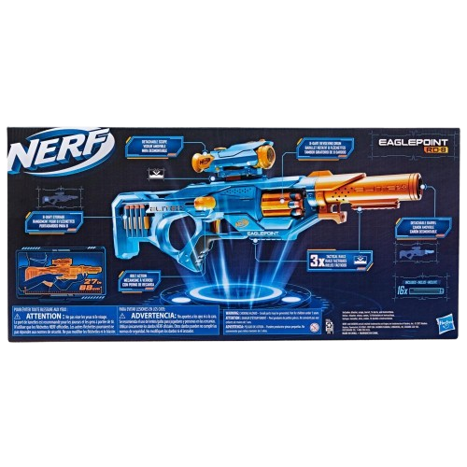****

**Nerf Elite 2.0**

**Price: $19.99**

**Experience the speed and precision with authentic design.**

**The Elite 2.0 blasters are modular**

**The Nerf Elite 2.0 series is an exciting line of blasters that takes Nerf’s classic dart-shooting fun to the next level with enhanced performance, customizable features, and a futuristic design. These blasters are built for superior accuracy and offering a range of models suited for different play styles**

**.**

.

**Product details**

**THANK YOU!**

**WELLCOME TO OUR WEBSITE**